Best Practices in Teaching-Learning Process
Dr. S. M. Jigajinni

- Active learning Strategies in the classroom

1.1 Think-Pair- Share (TPS)
In order to actively engage the students during the offline classes, and make the class interactive, TPS activity is conducted in every class for about 3-5 minutes. Students learn from each other. It includes all the students in the teaching learning process. TPS activity itself shares the three stages.

- For an individual student to think and answer about the question posed by the faculty (≈1 min.).
- To deepen the students understanding of the topic, instructor asks another question related to previous one. In the pair phase, their share their thinking with each other and proceed with the task. (≈2min).
- Finally, students share their thinking (or solution) to the entire class (≈3min).
Example
In the fifth-semester Metal Forming course, the instructor uses an LED projector to display various metallic objects in the classroom. The instructor then poses questions about the different manufacturing processes used to create these objects. Students respond using the TPS (Think-Pair-Share) technique, which encourages active participation. It was observed that 60% of students actively engaged in the activity, benefiting from both individual reflection and peer discussions.

1.2 Peer Instruction
Pedagogy technique for effective engagement of the students in the classroom. It is a active learning strategy which is structured around well-defined questions. It is a classroom active learning strategy based on specific, well-designed questions.
Anatomy of peer Instruction:

- Course Istructor asks the question (MCQ).

- Students Vote individually without discussing with their peers.

- Students discuss with each other and vote for the second time.

- Course instructor brief the summary about the answer and resumes with the lecture .

Advantages:
1. Students with common misconceptions can be overcome by discussing with their peers.
2. Entire class changes its opinions or choices based on the interaction they have with their peers.

1.3 Predict-Observe- Explain (POE)

LEARNER (Student) TEACHER

Observes the Visual Plays the Video up to a strategic point

Predicts and Discusses Pauses the Video what will follow

Watches Videos and explains: Shows the rest of the Visual
Concept understanding and reasoning

Multiple features of smart board fitted in the class room could be used in order to make this activity effective. It starts with

- Facility that allows multiple video formats to be opened on the smart board

- Allows the touch screen to play/pause the video where it wants to (Easy to control playback)

- Allows to take a note layer and create notes, annotation and highlighting the content.

- Explanation phase by screen sharing the content to the students, so that the students can take home the notes.

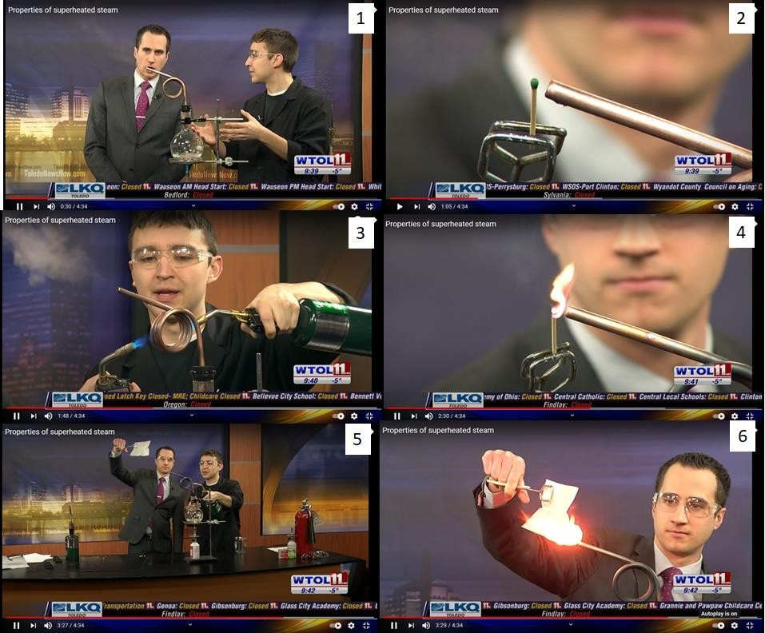
Fig. Demonstration of formation of Wet Steam (2 and 3) Dry steam (4) and Superheated steam (5 and 6) using POE Technique for the First year course on Elements of Mechanical Engineering (2022-23) (https://www.youtube.com/watch?v=8InpXBbjtPU&t=31s).

- Flipped Classroom
- Lower levels of Blooms Taxonomy: at home (50%) and in the class (50%)
(Sharing books with clearly identified chapter sections, video lectures, and Power Point Presentations via students WhatsApp group to support the development of foundational skills in Bloom's Taxonomy, specifically focusing on the Remember and Understand levels.).
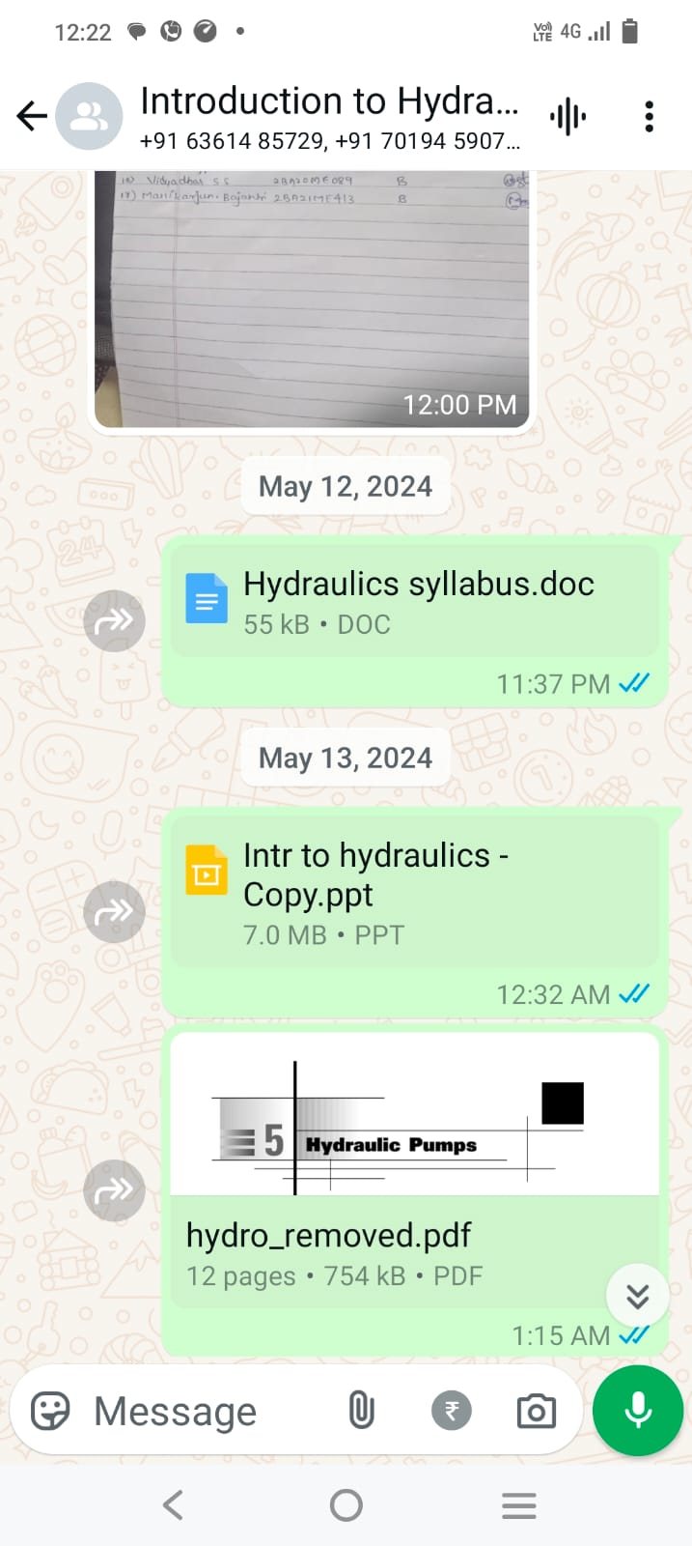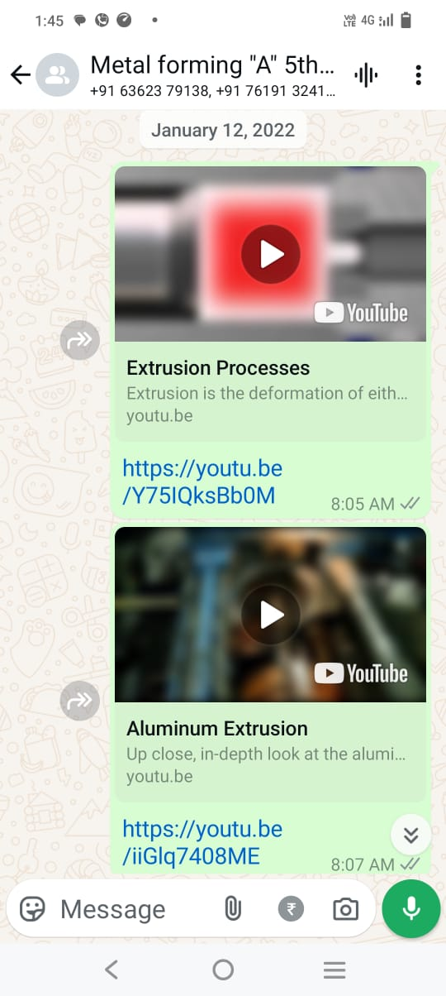
Fig. Syllabus content (ppts, Chapter Sections of Chapters, Videos) shared to the students in whatsap group.
- Higher levels of Blooms Taxonomy (Apply and Analyse): in class (100%)

- Problem Based Learning (PBL) and Problem Solving
Presenting the problem (or application) first, followed by the information needed to solve it, can more effectively engage students by providing a contextual framework that helps them process and understand abstract concepts.
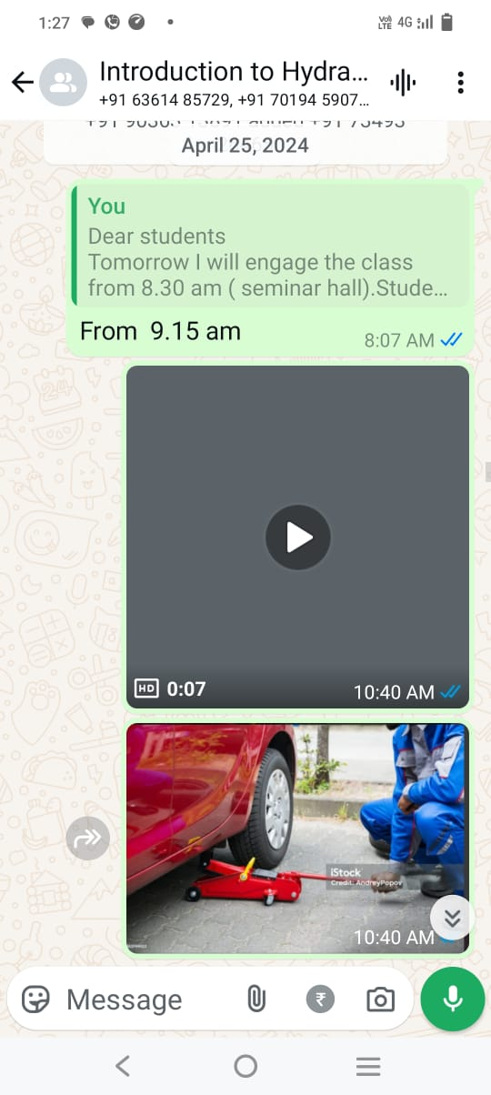
Fig. Demonstration of how a manually operated hydraulic jack is used to lift a car, and then engaging the students in designing the hydraulic circuit for the jack for the Eighth Semester Course on Introduction to Hydraulics (2023-24).

- Cooperative Group Learning
Less skilled group members improve their abilities by interacting with peers towards a shared goal. More skilled members feel satisfied when helping others in an informal setting and gain clarity themselves by explaining concepts to their teammates.
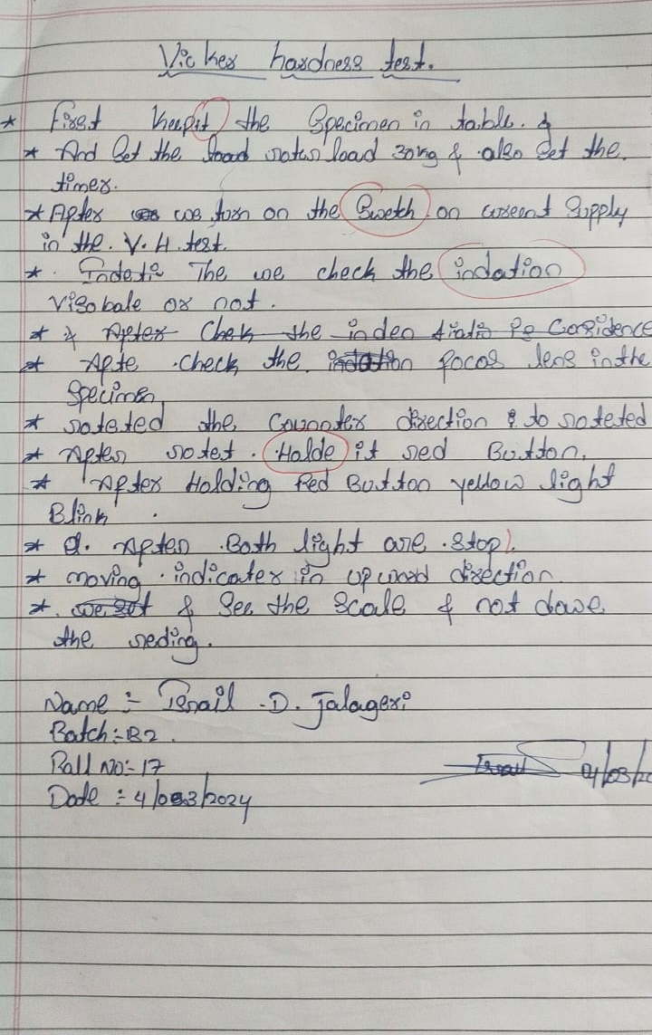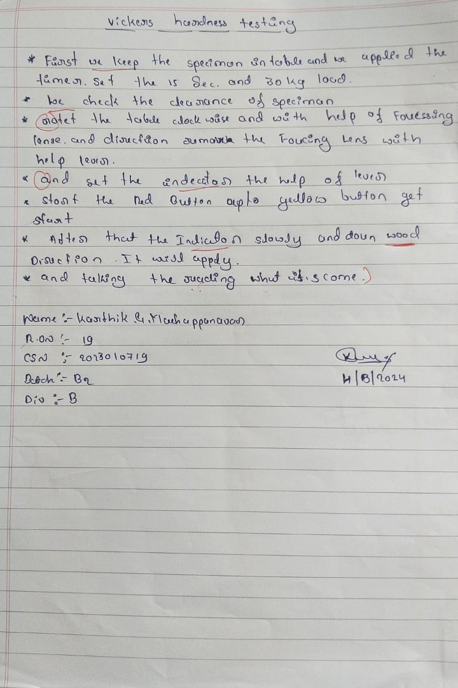
Fig. Procedure of the Vickers hardness test, as outlined by the students after conducting the experiment of the Fourth Semester Lab on Materials Testing and Instrumentation.
In the materials testing lab, after completing an experiment, students are asked to write the procedure they followed. Then, each student takes turns reading their procedure. After each reading, other students comment on any missing steps or mistakes and suggest corrections. This helps improve their communication skills.

- Learning Dialogue (LeD): Content + Reflection Spot
- Learning by Doing (LbD): Activities +Customised Feedback
- Learning eXtension Trajectories (L_{X}T): Resources +Assimilation Quizes
- Learner eXperience Interaction (LxI): Focus Question for Discussion+ Peer Interaction+ Reflection Quiz

List of NPTEL Courses completed by Dr S. M. Jigajinni during 2021-24:
- Teaching-Learning, OBE and NBA
Sl. No. | Title | Percentage | Year | Organisation
 | 4-week course on Outcome Based Pedagogic Principles for Effective Teaching | 93%,  Topper with 1% band | 2022-23 | IIT Kharagpur
 | 12-week course on NBA-Accreditation and Teaching-Learning in Engineering (NATE) | 88%, Topper with 2% band | 2023-24 | IISc Bangalore
 | 8-week Course on Accreditation and Outcome Based Learning | 91%,  Topper with 5% band | 2022-23 | IIT Kharagpur
 | 4-week course on Designing Learner Centric MOOCs | 90% | 2022-23 | IIT Bombay
 | 4-week course on Effective Engineering Teaching in Practice | 84% | 2023-24 | IIT Madras
 | 4-week course on Teaching and Learning in Engineering (TALE) | 86% | 2022-23 | IISc Bangalore
 | 4-week course on Introduction to Professional Scientific Communication | 78% | 2023-24 | IIT Kanpur

- Mechanical Engineering Courses
Sl. No. | Title | Percentage | Year | Organisation
 | 12 week course on Automation in Manufacturing | 92%, Topper with 2% band | 2023-24 | IIT Guwahati
 | 4 week course on Product Design and Development | 85% | 2021-22 | IIT Roorkee

